Product Requirements Specification (PRS)

- Product Vision & Intent
The project aims to simplify GST verification for MSMEs by providing an AI-powered system that automatically extracts, validates, and analyzes invoice data. It reduces dependency on auditors and manual processes by enabling quick detection of errors and mismatches. The goal is to improve accuracy, save time, and make GST compliance easy and accessible for non-technical users.

The Problem

Auditor Dependency: MSMEs rely heavily on auditors for GST verification, making even basic checks time-consuming and dependent on external support.

Error-Prone Processes: Manual record-keeping through bill books leads to frequent errors and unnoticed mismatches in invoices.

Lack of Transparency: Absence of proper tools makes it difficult for business owners to clearly understand and track their GST data.

Target Audience
- Primary: MSME business owners with low GST knowledge who rely on manual records like bill books and spreadsheets.
- Secondary: Accountants or support staff who assist in managing invoices and need quick validation and error detection.

2. Scope Definition
This project focuses on core GST validation and mismatch detection for a clean and focused implementation.
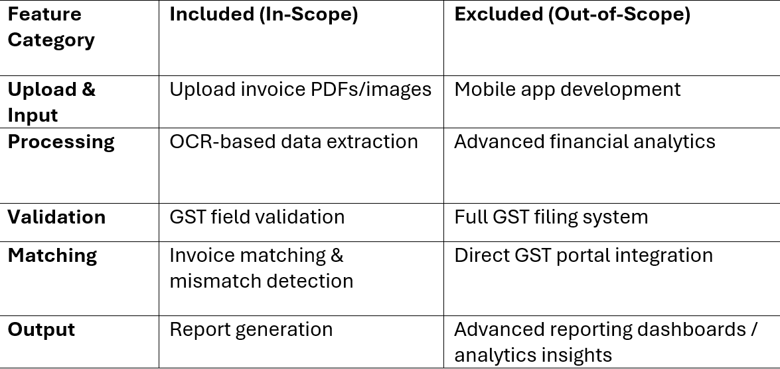

3. Functional Requirements
The system must act as an intelligent GST assistant that accurately processes and validates invoice data.
- Capabilities: The system extracts invoice data using OCR and validates key GST fields like GSTIN, amount, and date.
- Workflow: User uploads invoice → system extracts data → validates fields → detects mismatches → displays results.
- Business Logic: Invoices are considered valid only if GST rules are satisfied, and mismatches or duplicates are automatically flagged.

4. Non-Functional Requirements
To ensure efficient GST processing, the system must be fast, reliable, secure, and scalable.
- Performance: The system should process and validate invoices within a few seconds to provide quick results.
- Scalability: The architecture should support increasing numbers of users and invoice uploads without performance degradation.
- Reliability: The system should maintain high availability (around 99% uptime) and handle errors or invalid inputs gracefully.
- Security: All user and invoice data must be securely stored, with access restricted to authorized users only.

5. Data & Integration Requirements
Smooth operation depends on structured data handling and reliable processing components.
- Key Entities: The system manages data related to invoices, users, and GST details for validation and analysis.
- Integrations: The system may utilize OCR tools and backend processing modules to extract, validate, and analyse invoice data efficiently.

6. UX, Accessibility & Interaction Principles
The system is designed to be simple and user-friendly for non-technical users.
- Simplicity: The interface should be minimal and easy to use, allowing users to upload invoices and view results with minimal steps.
- Accessibility: The system should be usable by users with basic digital knowledge on standard devices like laptops or desktops.
- Clarity: Results, errors, and mismatches should be clearly displayed in a simple and understandable format.

7. Observability, Metrics & Monitoring
Continuous tracking ensures system performance and helps identify issues early.
- Monitoring: The system tracks metrics such as number of invoices processed, mismatch/error rates, and system response time.
- Alerts: Automated alerts are triggered for high error rates, processing failures, or abnormal system behaviour.

8. Risks, Assumptions & Dependencies

Potential challenges and dependencies are identified to ensure smooth system operation.

Risks: Poor image quality may reduce OCR accuracy, and incorrect or incomplete uploads can lead to validation errors.

Assumptions: Users have basic digital access and upload readable invoice formats.

Dependencies: The system depends on OCR tools and backend processing modules for accurate data extraction and validation.

9. Validation & Release Criteria
The system will be deployed only after meeting all functional and performance standards.
- Functional Checks: The system must accurately extract invoice data, validate GST fields, and correctly detect mismatches during testing.
- Performance Checks: The system should handle multiple invoice uploads simultaneously without delays or failures.
- Ready for Launch: All critical bugs must be resolved, and monitoring mechanisms must be fully operational.

